* **Name of the Activity:** Webinar on "Leave Rules, Service Book & Related Issues of Govt. Sponsored/Govt. Aided Colleges of West Bengal"
* **Type of the Activity:** Webinar
* **Organizing Department:** IQAC, Chakdaha College
* **Date and time of the Activity:** 30.05.2021 from 18.30 pm – 21.30 pm
* **Link of the Programme:** <https://youtu.be/sl3B-Wa2WVg>
* **Speakers:** Dr. Partha Karmakar, Deputy Secretary (Academic), WBBSE
* **Photograph of the Programme:**
* 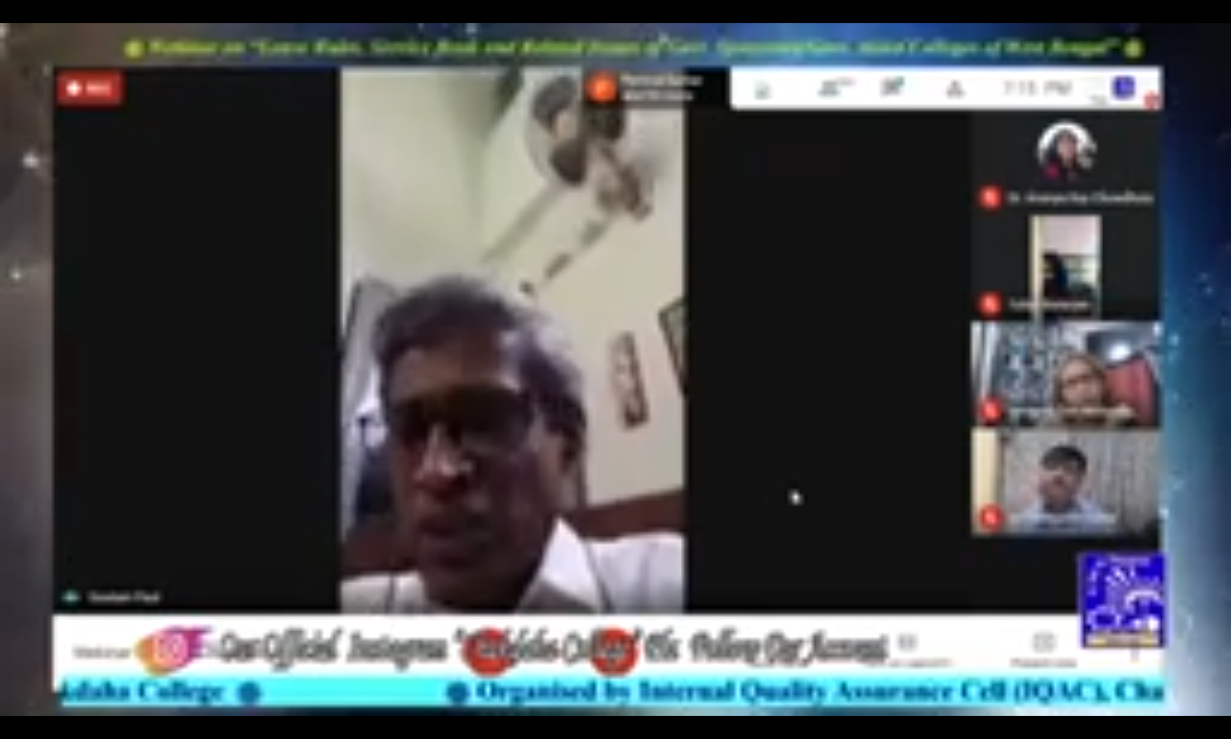
* **Number of Views:** 1600
* **Outcome:** The seminar at Chakdaha College delved into the crucial topics of Leave Rules, Service Book, and related issues specifically pertaining to Government Sponsored/Government Aided Colleges in West Bengal. The insightful discussions and presentations by distinguished experts shed light on key aspects, providing a comprehensive understanding for the participants.